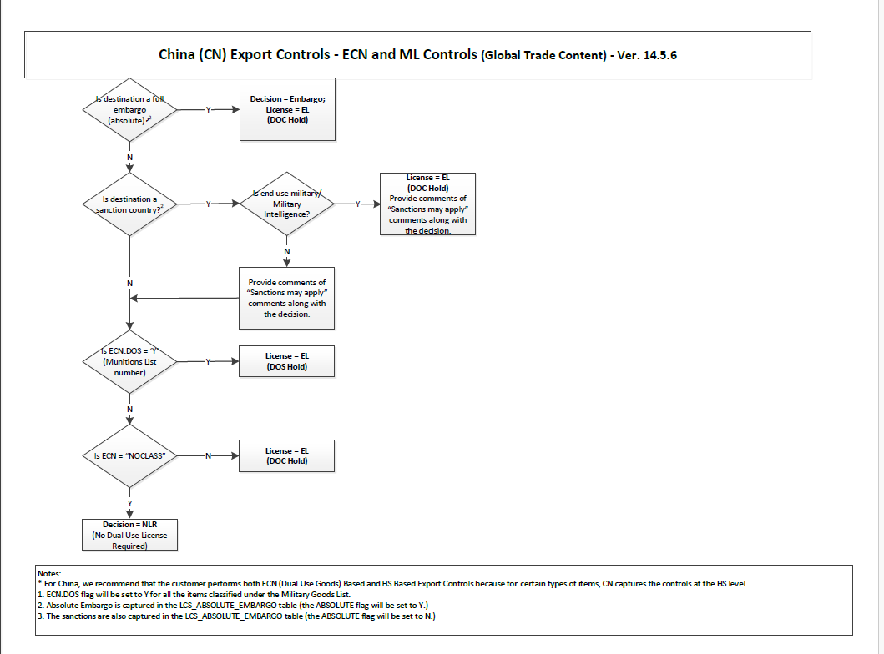
Above is the China country flow chart.
Write down a python program which will generate the agent.md file ,name it as LREQ Agent
- Read each condition mentioned in the flow chart
- For each condition, cover Y and N flow
- There are numbers mentioned in the flow chart, which are nothing but the superscripts. Refer the superscript numbers. These numbers are typically used as footnote indicators or reference markers. These are present in the Note section at the bottom of the page.

